AMERICAN SOCIETY OF PROFESSIONAL ESTIMATORS – OC CHAPTER 3
Presents

High Performance Architectural Envelope Systems
Presented by: Matt Stephens, Principal, Triton Building Products

Date: Wednesday, April 13, 2022

Time: 4:30 PM – 5:30 PM PST

Location: Microsoft Teams meeting, Join on your computer or mobile app: Click here to join the meeting

Or call in (audio only): +1 925-412-3623, ID: 316 303 431#
Triton Building Products is a manufacturer’s representative, servicing Southern California, for several of the leading rainscreen panel manufactures from around the world. Our product offerings include stone, terra cotta, porcelain, fiber cement, and metal panels.

Learning Objectives:
- Rainscreen panel system components
- Performance and Compliance (Thermal and Structural)
- Estimating System Materials and Labor Costs
- Optimization and Value Engineering
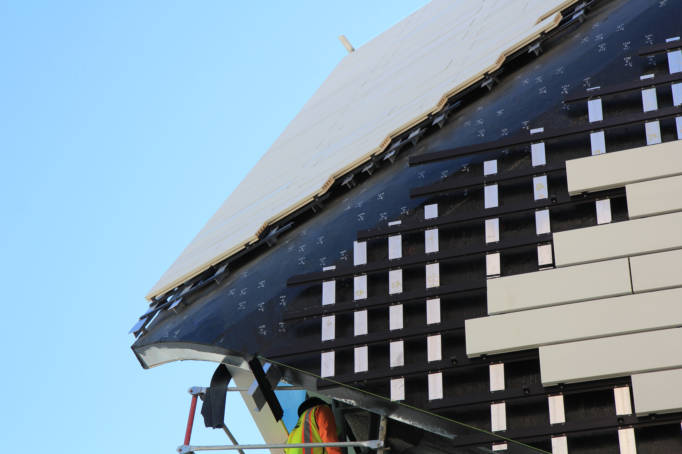

EDUCATION
ETHICS
STANDARDS
CERTIFICATION
FELLOWSHIP
PROFESSIONALISM

